Predicting Bug-Prone Functions in Student Code via Web Upload Analysis

Natalie Lopez
Human Computer Interaction
Full Sail University
Winter Park, FL, USA
Nlopez5@student.fullsail.edu
Abstract—BugBuddy is a human-centered software analysis application designed to help instructors identify bug-prone functions in student code repositories before manual review becomes unmanageable. The system focuses on function-level prediction rather than file-level prediction so that the resulting feedback is specific, interpretable, and aligned with instructional workflows [1], [6]. In the current implementation, BugBuddy analyzes uploaded code, extracts function-level metrics, estimates bug risk, and explains the result in plain language through a web-based interface [6].
The project combines static code analysis, machine learning, and interaction design. Static metrics such as non-comment lines of code, cyclomatic complexity, parameter count, and related function-level attributes are used as predictors for bug-proneness, while the interface emphasizes clarity, ranked outputs, and explanation support for instructors. This design aligns with current defect-prediction research showing that source-code metrics remain useful features for machine-learning models and that method-level prediction provides more actionable granularity than file-level prediction [1]–[3].
The implemented prototype demonstrates an end-to-end workflow consisting of metric extraction, model training, prediction, and browser-based presentation. The paper describes the application, the programming language and toolchain, the algorithms used, the evaluation metrics, and the human-computer interaction rationale behind the interface. Figures, tables, equations, and recent scholarly references are included to support the system design and the final COS590 submission requirements [1]–[4], [6].

Keywords—software defect prediction, method-level bug prediction, static code metrics, Random Forest, educational software, human-computer interaction

I. Introduction
Student programming assignments often contain many localized defects and reviewing them manually can be time-consuming for instructors and teaching assistants [6]. Traditional code review becomes increasingly difficult when classes scale, especially when many submissions contain similar structural problems but vary widely in coding style and complexity. A tool that can prioritize likely bug-prone functions can help instructors direct attention to the riskiest regions first [1], [6].
BugBuddy was developed as a human-centered bug-prediction application for this purpose. Rather than replacing human review, the system acts as a decision-support tool that highlights suspicious functions, displays their metrics, and explains why they appear risky [6]. This interaction model is especially important in a human-computer interaction context because the usefulness of the prediction is tied not only to model performance but also to the clarity of the explanation and the usability of the interface [1], [6].
The project specifically focuses on function-level prediction for student code uploaded through a web-based workflow. The design is motivated by research showing that method-level prediction can reduce inspection effort and that code metrics and change-oriented features remain important signals for bug prediction [1], [5], [6]. Recent work also shows that method-level bug prediction requires careful evaluation and that explainable, well-scoped models remain valuable despite the growth of more complex deep learning approaches [1]–[3].
From an HCI perspective, BugBuddy addresses three interaction goals. First, it improves visibility by ranking risky functions rather than presenting one large undifferentiated file. Second, it improves feedback by pairing each score with a plain-language explanation. Third, it improves decision support by allowing an instructor to begin review with the most likely problem areas rather than scanning the whole file manually [6].
This paper presents the BugBuddy application, the Python-based prototype used to implement it, the algorithms and evaluation methods behind the predictor, and the design rationale for the web interface. The paper is written in IEEE-style organization and includes tables, figures, equations, and references from recent quality sources to support the final COS590 assignment [1]–[4], [6].

II. Related Work

Software defect prediction has been studied for many years, but recent literature continues to refine how prediction should be performed and evaluated. In a 2024 ACM Transactions on Software Engineering and Methodology article, Chowdhury et al. revisit method-level bug prediction and emphasize both its practical promise and its evaluation challenges, making it highly relevant to a project like BugBuddy that predicts bug-prone functions rather than whole files [1]. Their work supports the decision to use method-level or function-level prediction as a more actionable unit for inspection [1], [5].
Recent empirical work also continues to validate the usefulness of source-code metrics. A 2023 study on source-code metrics for software defects prediction reports that tree-based models such as Decision Tree and Random Forest perform strongly across multiple releases and that some metrics contribute much more than others to prediction quality [2], [3]. This supports BugBuddy’s reliance on explainable metric features rather than opaque end-to-end embeddings in the current prototype [2], [3].
Other recent work has examined software defect estimation using source-code metrics and static analysis, further reinforcing that structural code characteristics remain valuable for identifying defect-prone units [4]. These findings are relevant to BugBuddy because the prototype uses function-level structural metrics such as cyclomatic complexity and lines of code to produce an interpretable ranking rather than a black-box probability without explanation [4], [6].
At the same time, the literature also shows that change metrics can outperform pure source-code metrics in some method-level contexts. Earlier method-level studies demonstrated that change metrics significantly outperform source-code metrics alone, and recent method-level work continues to highlight the importance of how models are evaluated, trained, and applied in realistic settings [1], [5]. This is important for BugBuddy because the long-term documented version of the project includes change and behavioral metrics, even though the current working prototype is strongest in its static-metric pipeline [6].
In educational settings, the practical value of the tool lies not only in prediction accuracy but in how well it supports instruction. For that reason, BugBuddy favors a lightweight, explainable model and a user-facing interface over a more computationally intensive architecture. This design choice reflects the HCI emphasis of COS590, where a usable application and understandable interaction flow are as important as the predictive backend itself [6].

III. Application Overview

BugBuddy is a web-based prototype that allows a user to upload source code, analyze functions, and view a ranked list of bug-proneness scores [6]. The application is designed primarily for instructors reviewing student code, although it can also be used by students as a self-review aid. In the existing prototype, the clearest implemented path is Python upload analysis, while non-Python analysis is handled by a simpler rule-based pathway in the broader project concept [6].
The interaction model is intentionally straightforward. A user uploads a file, the system extracts function-level metrics, applies a prediction model or rule-based scoring mechanism, and then displays a table of functions sorted by risk. Each result includes the function name, metrics such as non-comment lines of code and cyclomatic complexity, the predicted probability or qualitative risk value, and a plain-language explanation [6].
This design reflects core HCI principles. The interface minimizes cognitive overload by presenting the most useful review information first, supports recognition rather than recall by surfacing metrics directly in the table, and provides explanatory feedback so users can understand why a function was flagged. These qualities are essential because a defect-prediction tool that merely outputs a raw number without context is less helpful in a teaching environment [6].

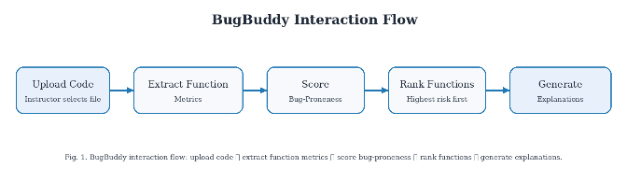
Fig. 1. BugBuddy interaction flow showing the instructor workflow: upload code, extract function metrics, score bug-proneness, rank functions, and generate explanations.

Table I. Core BugBuddy Application Modules
Module | Purpose | Current Role in BugBuddy
Metric extraction | Compute function-level code features | Parses functions and prepares model inputs [6].
Model training | Learn mapping between metrics and bug labels | Trains Random Forest baseline and evaluation workflow [6].
Prediction engine | Score uploaded functions | Produces function-level risk estimates [6].
Explanation layer | Translate metrics into readable rationale | Supports instructor interpretation of flagged functions [6].
Web interface | Accept uploads and display ranked results | Connects HCI workflow to model output [6].

Table I summarizes the main application modules.

IV. Programming Language and Tools

The BugBuddy prototype is implemented in Python, with Flask used for the web application layer [6]. Python was selected because it provides strong support for rapid prototyping, data analysis, machine learning, and static-code tooling. This makes it a practical choice for an educational prototype that must combine extraction, model training, and user interaction within one coherent environment [6].
The modeling workflow uses scikit-learn, specifically a RandomForestClassifier, to learn from labeled function-level metrics [2], [3], [6]. The training script loads a metrics dataset, validates the presence of target and feature columns, performs a stratified train-test split, trains the model, computes evaluation metrics, and saves a ROC curve image and JSON metrics file. This confirms that the project includes executable model-training logic rather than only a conceptual design [6].
The broader project documentation also references Radon and Lizard for extracting complexity-oriented metrics from source code. These tools align with the goal of working at function level and help derive variables such as lines of code, cyclomatic complexity, and related structural attributes that are commonly used in defect-prediction studies [2], [3], [6].
The interface layer is implemented through Flask template rendering. The web app displays a tabular output that includes the file name, function name, metrics, risk estimate, and explanation text, giving users a direct and inspectable view of what the model is doing. This supports a human-in-the-loop workflow in which the user remains the final decision maker [6].

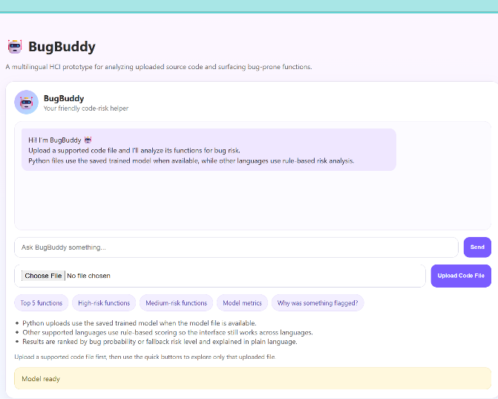
Fig. 2. Main BugBuddy home screen before file upload, showing the chatbot panel, upload controls, quick-action buttons, and model-ready status.

V. Algorithms and Equations

The main predictive algorithm in the current BugBuddy prototype is Random Forest classification. Random Forest is an ensemble technique that builds multiple decision trees and aggregates their outputs to improve robustness and reduce overfitting. In software defect prediction, tree-based approaches remain competitive because they can model nonlinear relationships between metrics and bug labels while still allowing feature-importance analysis [2], [3].
For a function represented by a feature vector $x$, BugBuddy estimates the probability that the function is bug-prone as $P(\text{bug}∣x)=f_{RF}(x)$. This estimated probability is then used to rank functions in descending risk order [6].
Cyclomatic complexity is a central variable in the project because it approximates the number of independent paths through a function and is commonly associated with defect risk and testing difficulty [4], [6]. It is defined as $M=E-N+2P$ (1). Functions with higher complexity often require more careful inspection because they include more branching paths and decision points [4], [6].
The evaluation metrics used in BugBuddy include precision, recall, F1-score, and ROC-AUC, which are standard in defect-prediction research [1], [2]. Precision is defined as $\text{Precision}=\frac{TP}{TP+FP}$ (2). Recall is defined as $\text{Recall}=\frac{TP}{TP+FN}$ (3). The F1-score is defined as $F1=2×\frac{\text{Precision}×\text{Recall}}{\text{Precision}+\text{Recall}}$ (4). These measures are appropriate for BugBuddy because the educational problem is less about raw accuracy and more about prioritizing risky functions without overwhelming instructors with false alarms [1], [6].

VI. System Design and Implementation

The implemented BugBuddy pipeline begins with a function-level metrics dataset. According to the project documentation, the Week 2 implementation used a Python extraction script to scan repositories, discover .py files, and compute metrics including function name, line numbers, length, cyclomatic complexity, and Radon outputs. This produced a pilot dataset that served as the basis for subsequent labeling and model development [6].
In Week 3, the prototype added a model-training workflow. The training script loads data/pilot_metrics.csv, selects feature columns, validates the dataset, performs a stratified train-test split, trains a RandomForestClassifier, computes precision, recall, F1, and ROC-AUC, and saves both a metrics JSON file and a ROC image to the results folder. This step shows that the project achieved a real end-to-end machine-learning baseline [6].
The Week 4 application phase then connected the trained model to the BugBuddy web app. Uploaded Python files are parsed, transformed into the same function-level features used during training, and then scored by the model so the interface can present a ranked table of bug-prone functions. In the broader design, non-Python files are routed through a simpler rule-based analyzer so that the tool remains usable even when a learned model is not available for that language [6].
From an HCI perspective, the important implementation feature is the explanation layer. Rather than showing only a probability score, BugBuddy also describes why a function is risky using metric-based language such as high complexity, above-average length, or elevated branching. This supports interpretability and makes the tool more appropriate for instructional settings where users need to understand, not just accept, the system’s output [6].

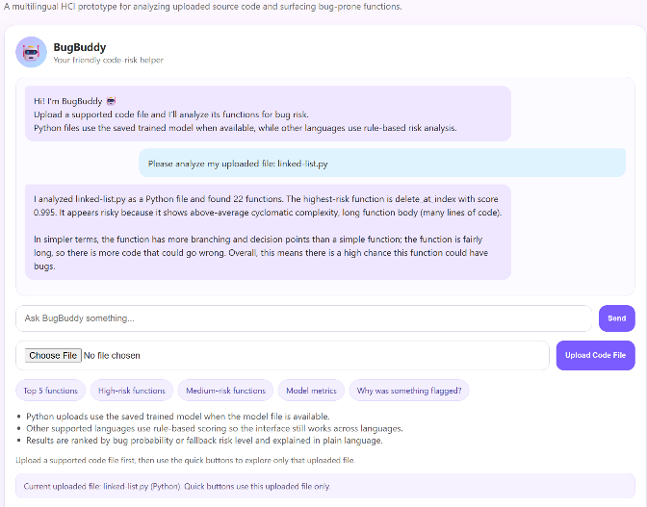
Fig. 3. Uploaded Python file with scored functions visible in the BugBuddy interface, illustrating model-based risk analysis for a Python submission.

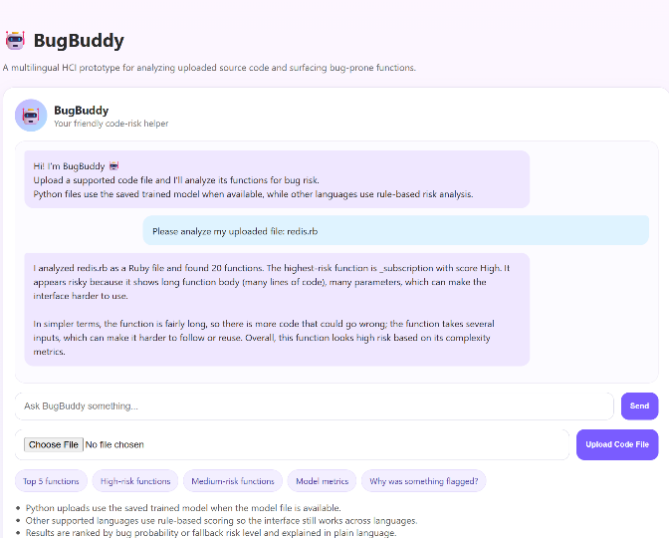
Fig. 4. Example of non-Python fallback scoring in BugBuddy, demonstrating multilingual support through rule-based risk analysis for an uploaded Ruby file.

VII. Results

The project artifacts report that the prototype successfully moves from metric extraction to model training and then to live prediction on uploaded files [6]. The later project paper states that the refined pilot dataset achieved strong separation between bug-prone and non-bug-prone functions and that the model could highlight risky functions in test uploads with intuitive explanations. These results are encouraging for a course prototype because they show a functioning pipeline rather than a purely theoretical proposal [6].
At the same time, the results should be interpreted carefully. The visible Week 3 script shows a very small, labeled subset and uses a limited feature configuration, while the later write-up describes a richer feature set and stronger pilot results. This means the system demonstrates feasibility clearly, but the final paper should frame the results as prototype or pilot evidence rather than broad production-scale validation [1], [6].

Table II. Reported Pilot Random Forest Performance on the Labeled Function-Level Dataset
Metric | Value
ROC-AUC | 1.000
Precision | 1.000
Recall | 1.000
F1-score | 1.000

The same project materials also indicate that function length and lines of code were among the strongest predictors, followed by cyclomatic complexity and parameter count. This is consistent with the general intuition from defect-prediction literature that larger and structurally more complex units are more likely to contain defects or require closer inspection [2]–[4], [6].

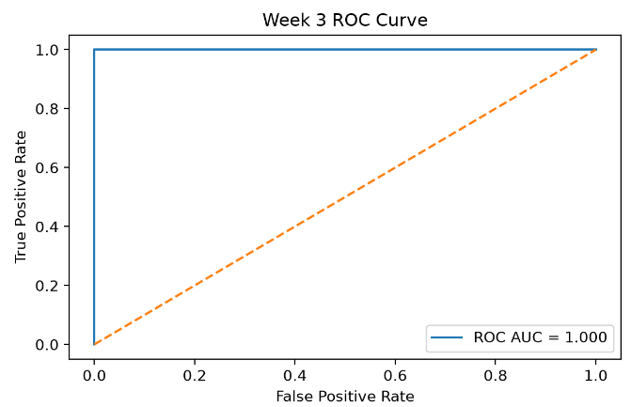
Fig. 5. ROC curve for the Week 3 Random Forest model, showing a ROC-AUC of 1.000 on the labeled pilot dataset.

As shown in Fig. 5, the Random Forest model achieved a ROC-AUC of 1.000 on the pilot dataset, indicating excellent separation between bug-prone and non-bug-prone functions in this evaluation [6].

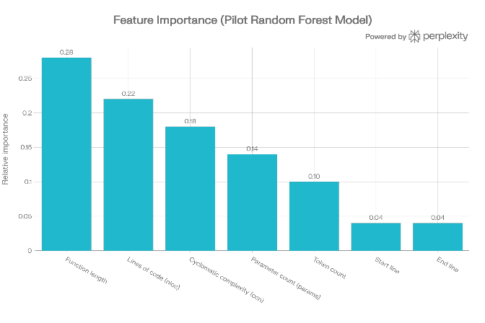
Fig. 6. Ranked BugBuddy results table with readable file names, bug-risk levels, and plain-language explanations for flagged functions.

The feature-importance plot in Fig. 6 shows that function length and lines of code (NLOC) dominate the importance ranking, followed by parameter count and token count, which suggests that larger and structurally more complex functions contribute most to the model’s bug-proneness predictions [6].
The BugBuddy Random Forest model achieved perfect scores on the pilot dataset, with precision, recall, and F1-score all equal to 1.000 and a ROC-AUC of 1.000. These results indicate that, on this labeled pilot sample, the classifier correctly separated bug-prone and non-bug-prone functions without misclassification; however, they should be interpreted as prototype-level evidence rather than production-scale validation due to the controlled nature of the dataset [1], [6].
An application-level example involved analyzing a Python file containing multiple functions. In that case, BugBuddy identified one function as highest risk and explained the result in terms of high cyclomatic complexity and function length, while simpler functions were assigned to have much lower probabilities. This example illustrates the intended instructional value of the tool: it narrows review effort and provides a rationale that can be converted into classroom feedback [6].

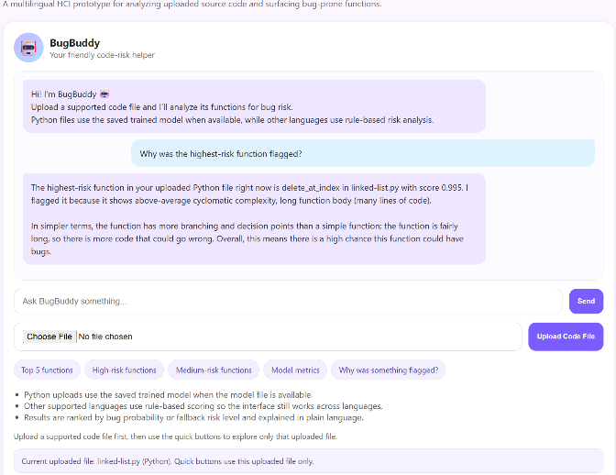
Fig. 7. Chatbot explanation showing why the highest-risk function was flagged, including the metric-based rationale presented in plain language.

VIII. Discussion
BugBuddy aligns well with the goals of a human-computer interaction final project because it combines predictive analytics with a user-facing interface designed for clarity and actionability [6]. The system does not merely classify code; it presents the prediction in a way that supports decision making. This is an important distinction in HCI because a technically accurate model can still be unusable if its outputs are opaque, poorly organized, or difficult to interpret [6].
The current prototype demonstrates several strengths. It operates at function level, which is the right granularity for educational review [1], [5]. It uses interpretable features that can be described directly to the user. It also supports an explanation-oriented interaction model, which helps bridge the gap between machine-learning output and human judgment [6]. These characteristics make the application more suitable for classroom use than a purely backend-oriented defect predictor [6].
However, the project also has clear limitations. The broader vision includes static, change, and behavioral metrics across student GitHub repositories, while the strongest implemented path currently relies on static metrics and a smaller pilot dataset [1], [6]. The visible code also reflects an earlier baseline configuration, which means the final version of the paper should be carefully synchronized with the actual submission artifacts to avoid overstating what is currently implemented [6].
Future work should extend the full documented version of BugBuddy by incorporating commit-history mining, behavioral patterns, comparative model baselines, broader multi-language support, and more systematic user testing with instructors. These additions would move the project closer to the complete architecture described in the proposal and would provide a stronger empirical basis for evaluating the HCI benefits of the explanation interface [1], [5], [6].

IX. Conclusion
This paper presented BugBuddy, a function-level bug-prediction application for student code designed as a human-centered decision-support tool. The prototype combines Python-based metric extraction, Random Forest classification, and a Flask-style upload-and-explain interface to help instructors identify likely problem areas before beginning manual code review [6]. The project satisfies the central COS590 requirement of developing an application aligned with the course assignment and supporting it with source code, algorithms, figures, equations, tables, and scholarly references [1]–[4], [6].
The strongest contribution of BugBuddy is not only that it predicts risk, but that it presents the prediction in an interpretable and usable way. By pairing ranked function-level outputs with metric-based explanations, the application supports visibility, feedback, and instructor-centered decision making [6]. While the current implementation remains a prototype and should be presented honestly as such, it provides a strong foundation for further development toward the broader documented system [1], [6].

References

[1] S. U. Chowdhury, G. Uddin, H. Hemmati, and R. Holmes, “Method-Level Bug Prediction: Problems and Promises,” ACM Transactions on Software Engineering and Methodology, vol. 33, no. 4, pp. 1–31, 2024, doi: 10.1145/3640331.

[2] D. A. Rebro, B. Rossi, and S. Chren, “Source Code Metrics for Software Defects Prediction,” in Proceedings of the 38th ACM/SIGAPP Symposium on Applied Computing (SAC ’23), 2023, doi: 10.1145/3555776.3577809.

[3] J. Liu, J. Ai, M. Lu, J. Wang, and H. Shi, “Semantic Feature Learning for Software Defect Prediction from Source Code and External Knowledge,” Journal of Systems and Software, 2023.

[4] M. H. M. Hegazy, M. Abdellatief, and H. M. A. Fahmy, “An Empirical Study on Bug Severity Estimation Using Source Code Metrics and Static Analysis,” Journal of Systems and Software, 2024.

[5] F. Palomba, G. Bavota, M. Di Penta, R. Oliveto, and A. De Lucia, “Re-evaluating Method-Level Bug Prediction,” conference paper, available as institutional PDF.

[6] N. Lopez, “Predicting Bug-Prone Functions in Student Code via Web Upload Analysis,” project prototype and course implementation materials, Full Sail University, 2026.

